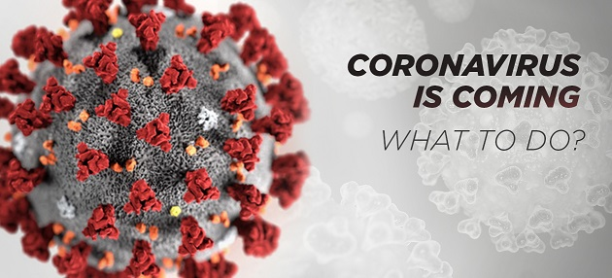
‘At the present time it is necessary for all the countries, communities, families and each individual to focus their attention on the preparations…We must focus our attention on holding down the virus, simultaneously taking all the measures possible for preparing for the potential pandemic.’ – claimed the CEO of the World Health Organization (WHO) on February 24th 2020.

The world is preparing for the global epidemic of the Chinese disease. Coronavirus is actively spreading worldwide. The cases of infecting are confirmed in more than 50 countries.
The official statistics from 27th of February:
- 81 218 people infected
- 2 801 people died
Each day the number of infected people is dramatically increasing. Only during the last day there were more than 900 people infected.
What is important to know about Coronavirus 2019-nCoV
This is a new strain of the coronavirus family which has not been observed in humans.
Coronavirus is passed by the airborne transmission, as well as through the direct contact with the infected animals, people or objects. The lifetime without the live carrier is not determined and can be more than an hour.
The supposed incubation period is 5-14 days.
The disease can occur both in mild form and cause severe damage to lungs, nervous system, gastrointestinal tract tissues.
The first symptoms of coronavirus in human are similar to the usual flu or cold: fever, cough, malaise, indigestion.
Progressing, Coronavirus 2019-nCoV affects lungs of the patient. 7 days after the first symptoms the patient has a severe form of pneumonia developing. Herewith the inflamed alveoli are easily filled with fluid, which interferes with normal gas exchange. This disrupts the breathing process, causing an acute oxygen deficiency in the tissues.
If the immunity of an infected person is weakened or he/she has severe comorbidities, there is a high probability of death.
The group of risk includes elderly people, children, people with weakened immune systems and chronic diseases.
Medicines against coronavirus
Currently there are no vaccines or medications against Coronavirus 2019-nCoV.
According to the World Health Organization, the first coronavirus vaccine will be available no sooner than in 12-18 months.

How to provide your safety during the Coronavirus 2019-nCoV epidemic
The infectious safety during the epidemic will be ensured by daily use of the bioresonance correction device BIOMEDIS TRINITY in order to prevent the disease.
It is known that the death of any virus occurs with the exposure of a resonant ultra-high frequency electromagnetic field.
TRINITY impacts the virus with the electromagnetic field of the ultra-high frequency resonant to the torsional oscillations of the virus’ DNA/RNA.
At the present time, the frequencies of numerous strains of coronavirus including Coronavirus 2019-nCoV have been calculated and uploaded into the device.
During the epidemic, it is extremely important to have strong immunity and good health.
BIOMEDIS TRINITY has a complex healing effect, based on the principles of bioresonance correction of the organism. With regular use, there launches the self-healing effect of the organism and strengthens the immune system.

How TRINITY kills the virus
It is known that the survival of the virus is determined by the degree of its division, that is, the ability to multiply.
The device impacts the DNA/RNA of the virus with a non-thermal resonant ultra-high electromagnetic field. Herewith, the frequency of exposure coincides with the natural frequency of torsional vibrations of Coronavirus 2019-nCoV DNA/RNA. As a result of this effect, the division process gets blocked, which leads to the death of the virus.

Before the division of the viral cell, the cyclic DNA/RNA breaks, one strand of DNA/RNA begins to unfold around another. Then, DNA/RNA bases are pulled to each strand. A DNA/RNA molecule has its own frequency of mechanical torsional oscillations. With the excitation of these oscillations, the molecule emits an electromagnetic wave in the ultra-high frequency range. Also, a DNA/RNA molecule is capable of absorbing ultra-high frequency waves. When a DNA/RNA molecule is impacted by a resonant ultra-high frequency electromagnetic field, the torsional vibrations get excited in it. An electromagnetic field with a DNA/RNA torsional vibration frequency prevents the bases and enzymes from contacting the strands of the DNA/RNA helix, i.e. interferes with the replication process and leads to the death of the virus.

Important! Since the level of the affecting electromagnetic field is non-thermal, and the frequency is resonant, then the field will impact only the specific DNA/RNA. As a result, the task of protecting the ‘carrier organism’ and the surrounding ecosystem as well as preserving the disinfected material without destruction is solved.
The impact is 100% safe for the virus carrier.
According to the same principle TRINITY deals with any viruses, bacteria, fungi, protozoa and helminths.
How TRINITY regulates work of organs and systems
The healing effect is based on the principles of bioresonance correction of the organism.
Each person is a source of physiological electromagnetic fields. Healthy cells and organs work with the oscillations frequency optimal for them.
Oscillations of a weakened organism deviate from the optimal values and the work of the organism gets disturbed.
BIOMEDIS TRINITY generates physiological electromagnetic frequencies and through the effect of bioresonance returns cells and organs to the optimal oscillations frequency.

How to apply BIOMEDIS TRINITY for the prevention and treatment of Coronavirus 2019-nCoV
For the prevention of coronavirus during the period of global epidemic it is recommended for everyone to apply the program CORONAVIRUS PREVENTION (complex 25)
Mode – 2
Signal strength – 100%
The duration of the complex is 5 hours 27 minutes.
With the first signs of weakness and malaise, in disease one should immediately apply the complex CORONAVIRUS TREATMENT (complex 26).
Mode – 2
Signal strength – 100%
The duration of the complex is 8 hours 33 minutes.
The complexes for prevention and treatment of coronavirus include antiviral programs, programs that regulate organs and systems, programs for detoxification and immunity stimulation.

